
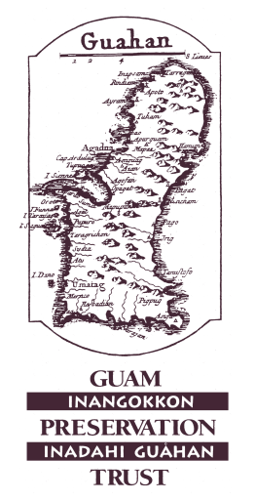
Guam Preservation Trust
P.O. Box 3036, Hagåtña, Guam 96932
Tel: 671-472-9439/40 Fax: 671-477-2047
SHOP: Supporting Heritage Oriented Projects
UPDATED 2025

Submission Date: ________________________________________
Applicant’s Name: ________________________________________
Applicant’s Address: _____________________________________
____________________________________
Telephone: (W) ________________ (Cell) _____________(Home) ___________
Email: __________________________________________________________
Duration of Project: ________________________ to: _____________________

Applicant’s School and Project Location: _______________________________
Teacher’s classroom grade level: ______
Primary subject area taught in class: _______
Name of School Principal:____________________________________________
Principal’s Contact Number: _________________________________________
I have made such steps as are necessary to verify the information given in this application package and attest that I am a teacher teaching at a Guam public or private school, and to the best of my knowledge and belief, all information is true, correct and accurate:

Applicant’s Signature: ____________________________________________
Thank you for your interest in Project S.H.O.P. We look forward to hearing about your project idea! In the lines below please answer the following two questions.

- What is your idea that will best incorporate Guam history, preservation, heritage, Chamoru culture in your classroom and when will you be able to implement it? (No more than 300 words)
________________________________________________________________________________________________________________________________________________________________________________________________________________________________________________________________________________________________________________________________________________________________________________________________________________________________________________________________________________________________________________________________________________
- How will you use the $500 and can you identify possible vendors on Guam? ( No more than 300 words)
________________________________________________________________________________________________________________________________________________________________________________________________________________________________________________________________________________________________________________________________________________________________________________________________________________________________________________________________________________________________________________________________________________

Application Due 4pm January 31, 2026. Form can be turned in to GPT office 167 Padre Palomo St, Hagåtña or by email to guampreservationtrust@gmail.com
GPT Evaluation Criteria:
- How achievable will your idea be implemented by the end of the 2025-2026 school year?
- How best you will incorporate Guam history, preservation, heritage, CHamoru culture in your idea?
- Can your supplies be purchased through local vendors?

Complete this form and submit it with your supporting documents.
Ways to submit:
In-person to the Guam Preservation Trust Office, 167 Padre Palomo Street, Hagatna
Email: guampreservationtrust@gmail.com

