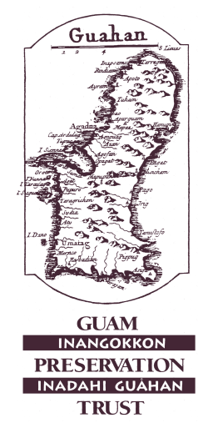
Guam Preservation Trust
P.O. Box 3036, Hagåtña, Guam 96932
Tel: 671-472-9439/40 Fax: 671-477-2047
UPDATED 2026
FINAL REPORT

SHOP: Supporting Heritage Oriented Projects

Submission Date: ___________________
Applicant’s Name: ________________________________________
Contact Information (Tel/Email):______________________________________
Applicant’s School and Project Location: _______________________________
Teacher’s classroom grade level: ______Primary subject area taught in class: _______
Number of students impacted by SHOP PROJECT:_________________
***
A Final Report is required to complete your participation in Project S.H.O.P. for SY 2025-2026. We look forward to hearing about how your project idea was implemented. In the lines below please answer the following questions:
- Did your idea incorporate Guam history, preservation, heritage, CHamoru culture in your classroom and how were you able to implement it? Any challenges or lessons learned? (No more than 300 words)
________________________________________________________________________________________________________________________________________________________________________________________________________________________________________________________________________________________________________________________________________________________________________________________________________________________________________________________________________________________________________________________________________________
- How did the classroom/school community benefit from the use of the $500 SHOP funds and what changes were you able to observe? (No more than 300 words)
________________________________________________________________________________________________________________________________________________________________________________________________________________________________________________________________________________________________________________________________________________________________________________________________________________________________________________________________________________________________________________________________________________
- Please provide the Guam Preservation Trust with copies of any print, digital, written or visual media that were funded by this grant. We also appreciate any other forms of media, including but not limited to videos, press articles, publications, and photographs that document your work. Guam Preservation Trust assumes permission to share any of the media with our community and stakeholders.

- Any additional comments or suggestions to improve the Project SHOP opportunity for future cycles?

_______________________________________________________________________________________________________________________________________________________________________________________________________________________________________________________________

***
I have made such steps as are necessary to verify the information given in this final report and attest that I am a teacher teaching at a Guam public or private school and recipient of PROJECT SHOP funds, and to the best of my knowledge and belief, all information is true, correct and accurate:
Applicant’s Signature: ____________________________________________
DUE 4PM FEBRUARY 28, 2027

